**Installing a Turbidity Sensor using an Arduino**

**The First Step: Connecting the Cables**

To start you will want to make sure you have done the lab where you connect the Arduino to the Raspberry Pi. Then disconnect all cables leading to the LED. Then we will need to route the ground and power from the Bi-Directional Level Converter into the positive and negative terminals on a breadboard. Like so:

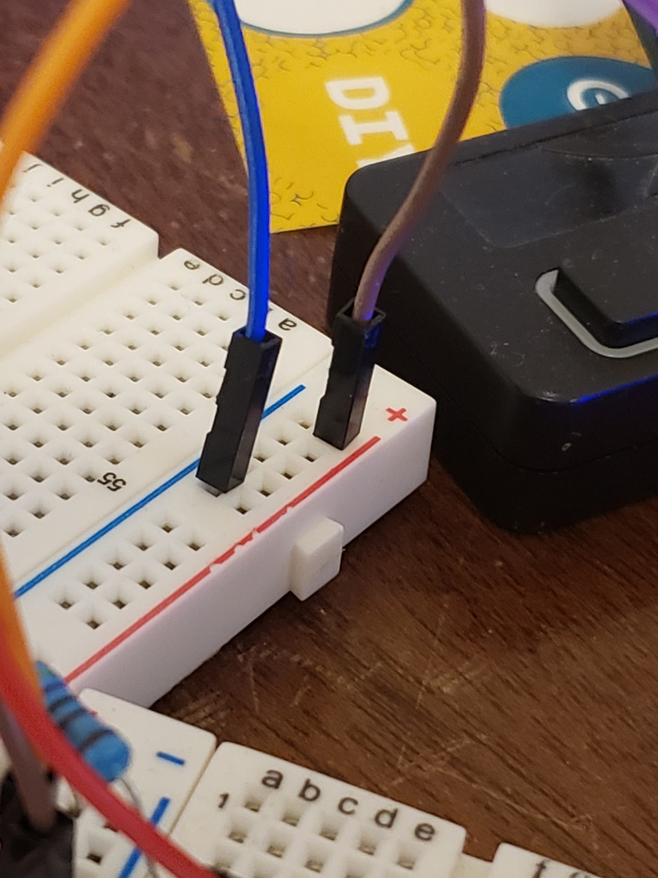

With these connected the idea will be to connect the power and ground from the turbidity sensor and arduino into the positive and negative rails.

So next you will need to get two male to male jumper cables to connect the 5V and GND pins on the Arduino to the respective positive and negative rails on the bread board, it should look like this:

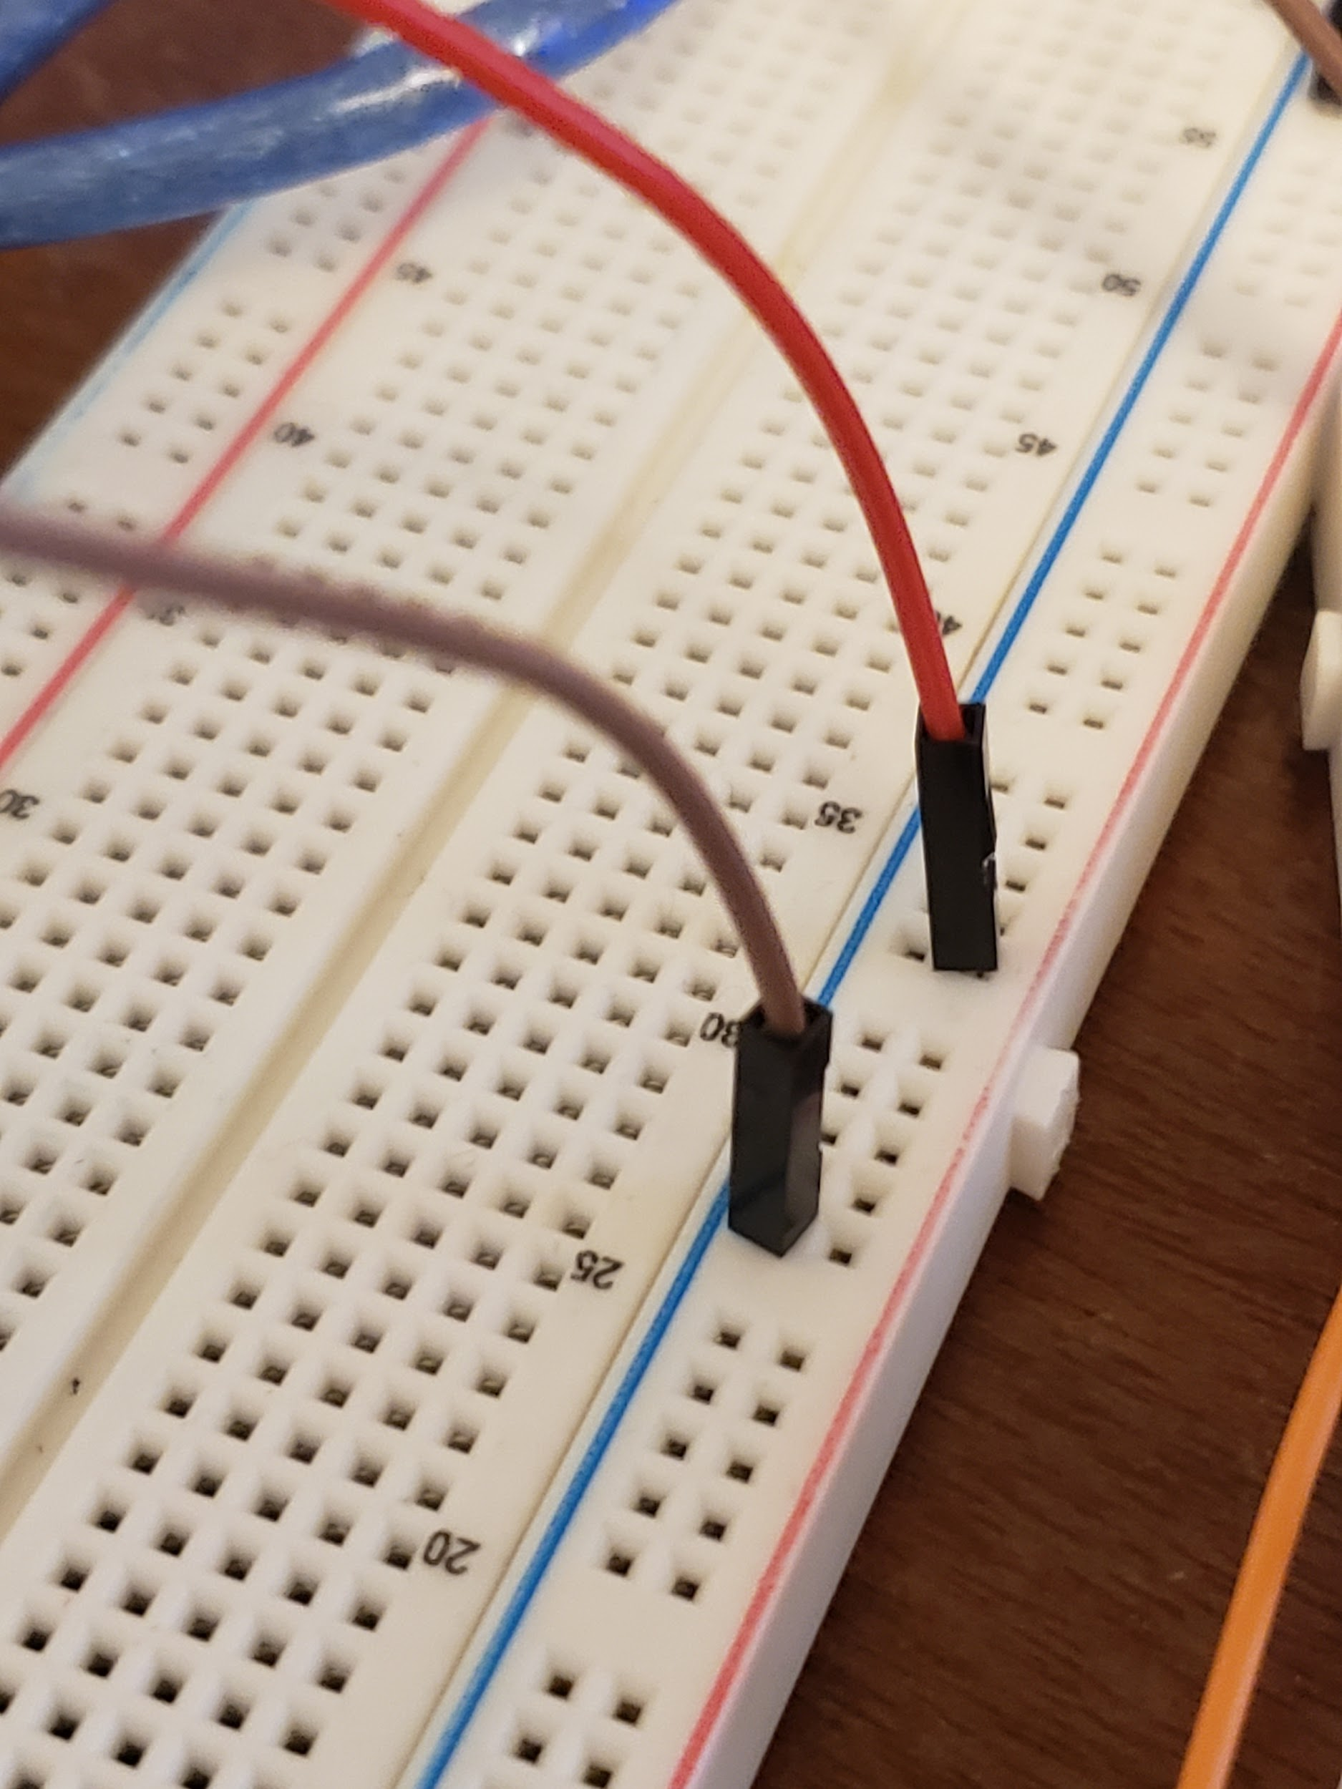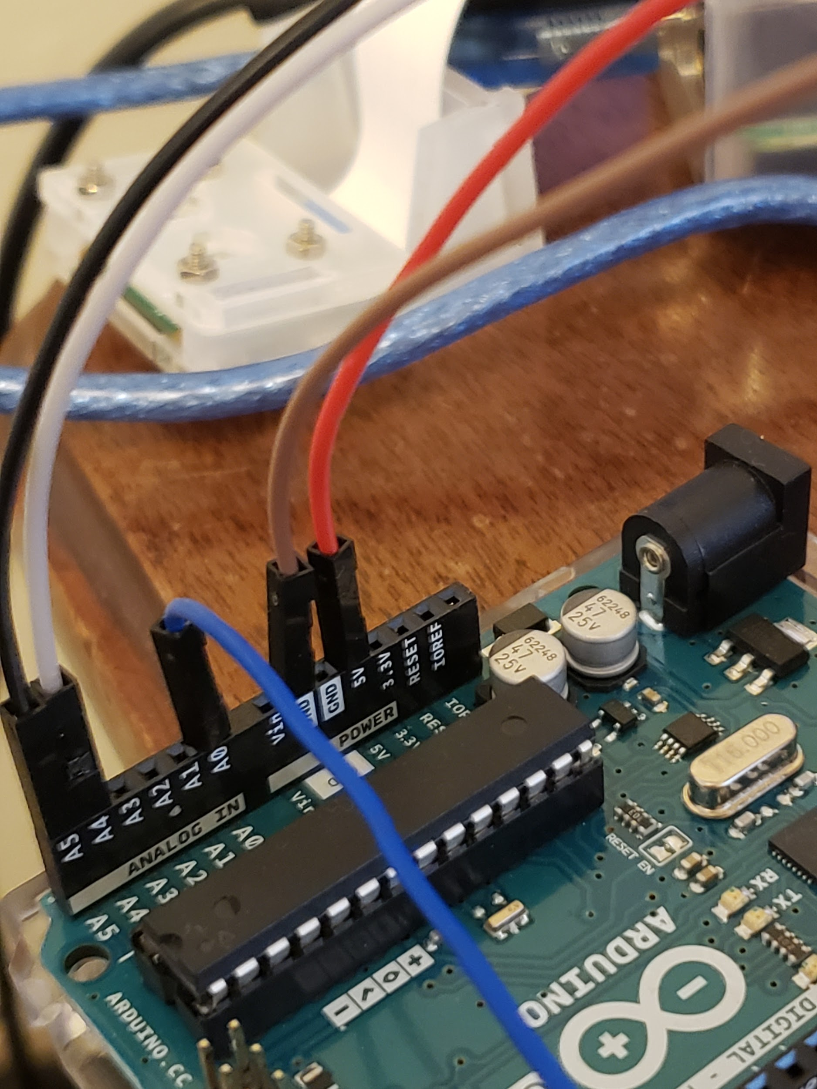

The red cable is the 5V and the brown is the GND cable. Now we will need to connect the turbidity sensor to the breadboard and arduino. To start connecting the turbidity sensor you will need to get three male to male jumper cables to connect the end of the sensor to the rest of the components.

It should look something like this:

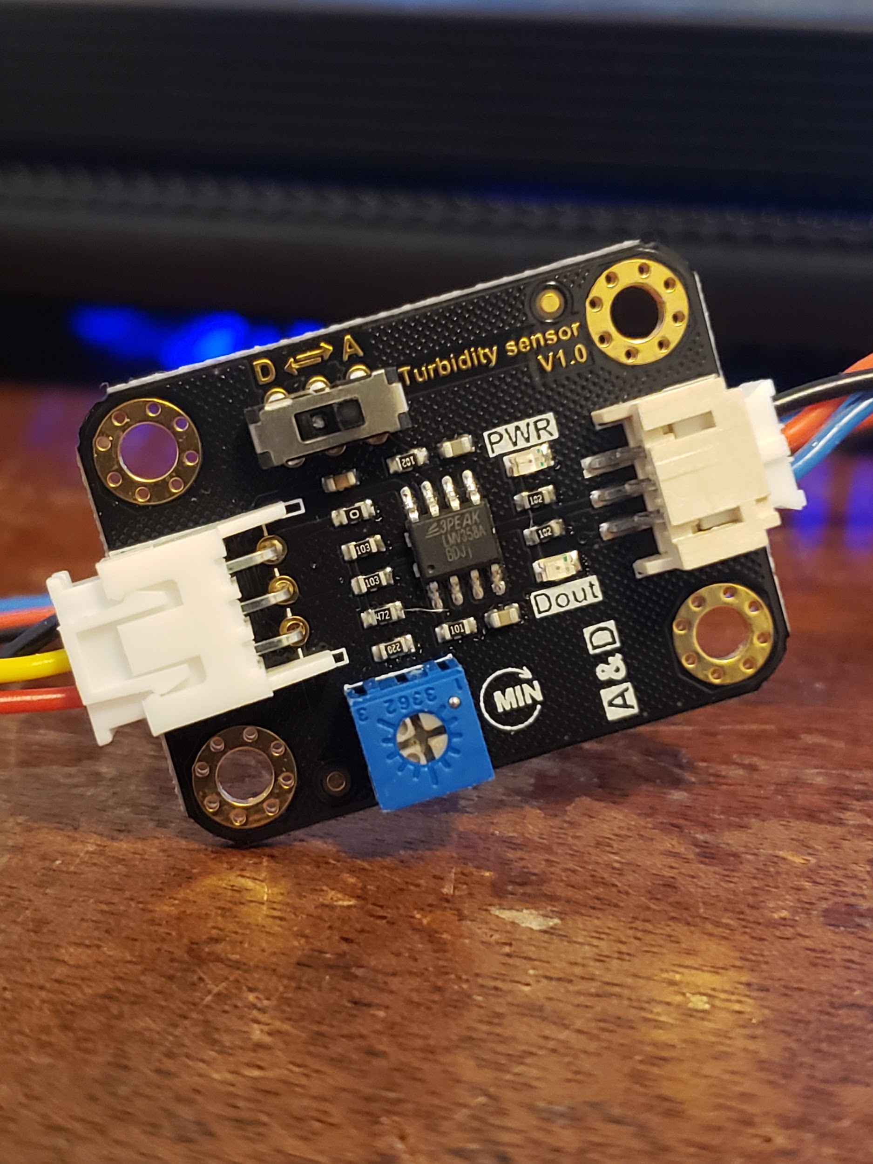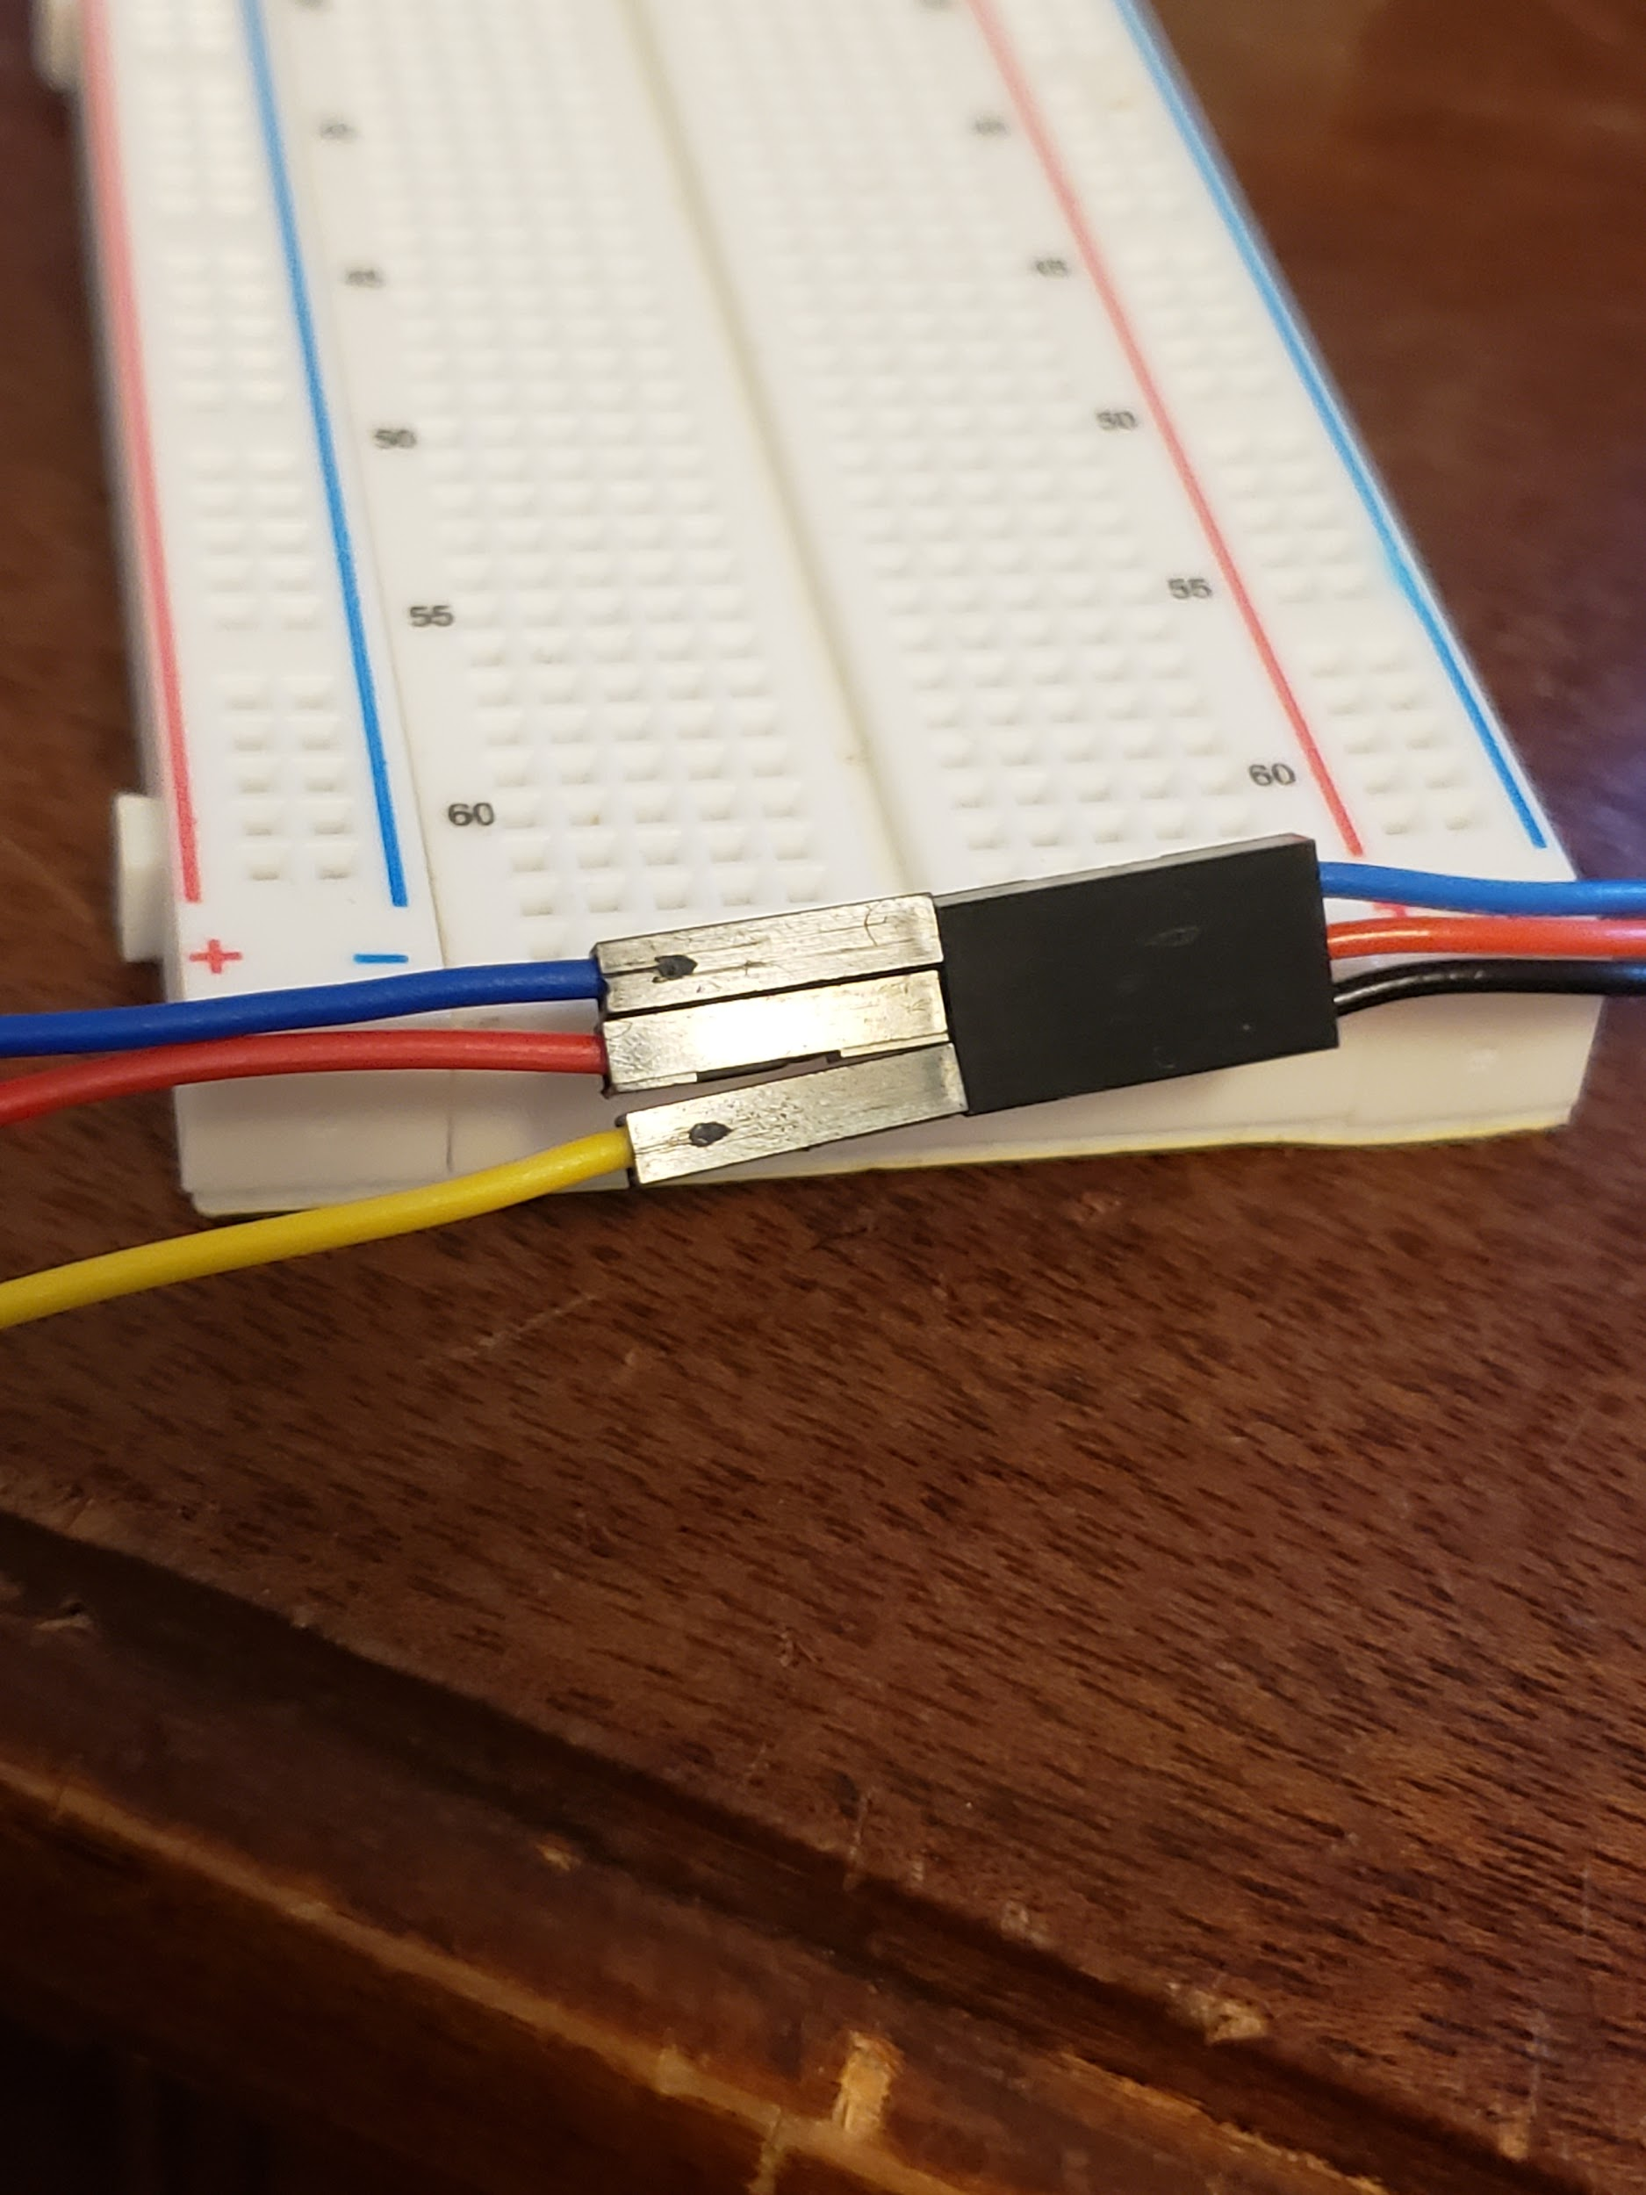

On the left is the A to D converter which we will have set on A. Then the three cables coming out of the right side of it will be connected to the arduino. The black pin is the ground, the red is the power, and the blue is the data. I have these connected to three jumper cables blue representing data, red is power, and yellow is ground. You then plug the blue jumper cable into the A0 port on the Arduino, it should look something like this:

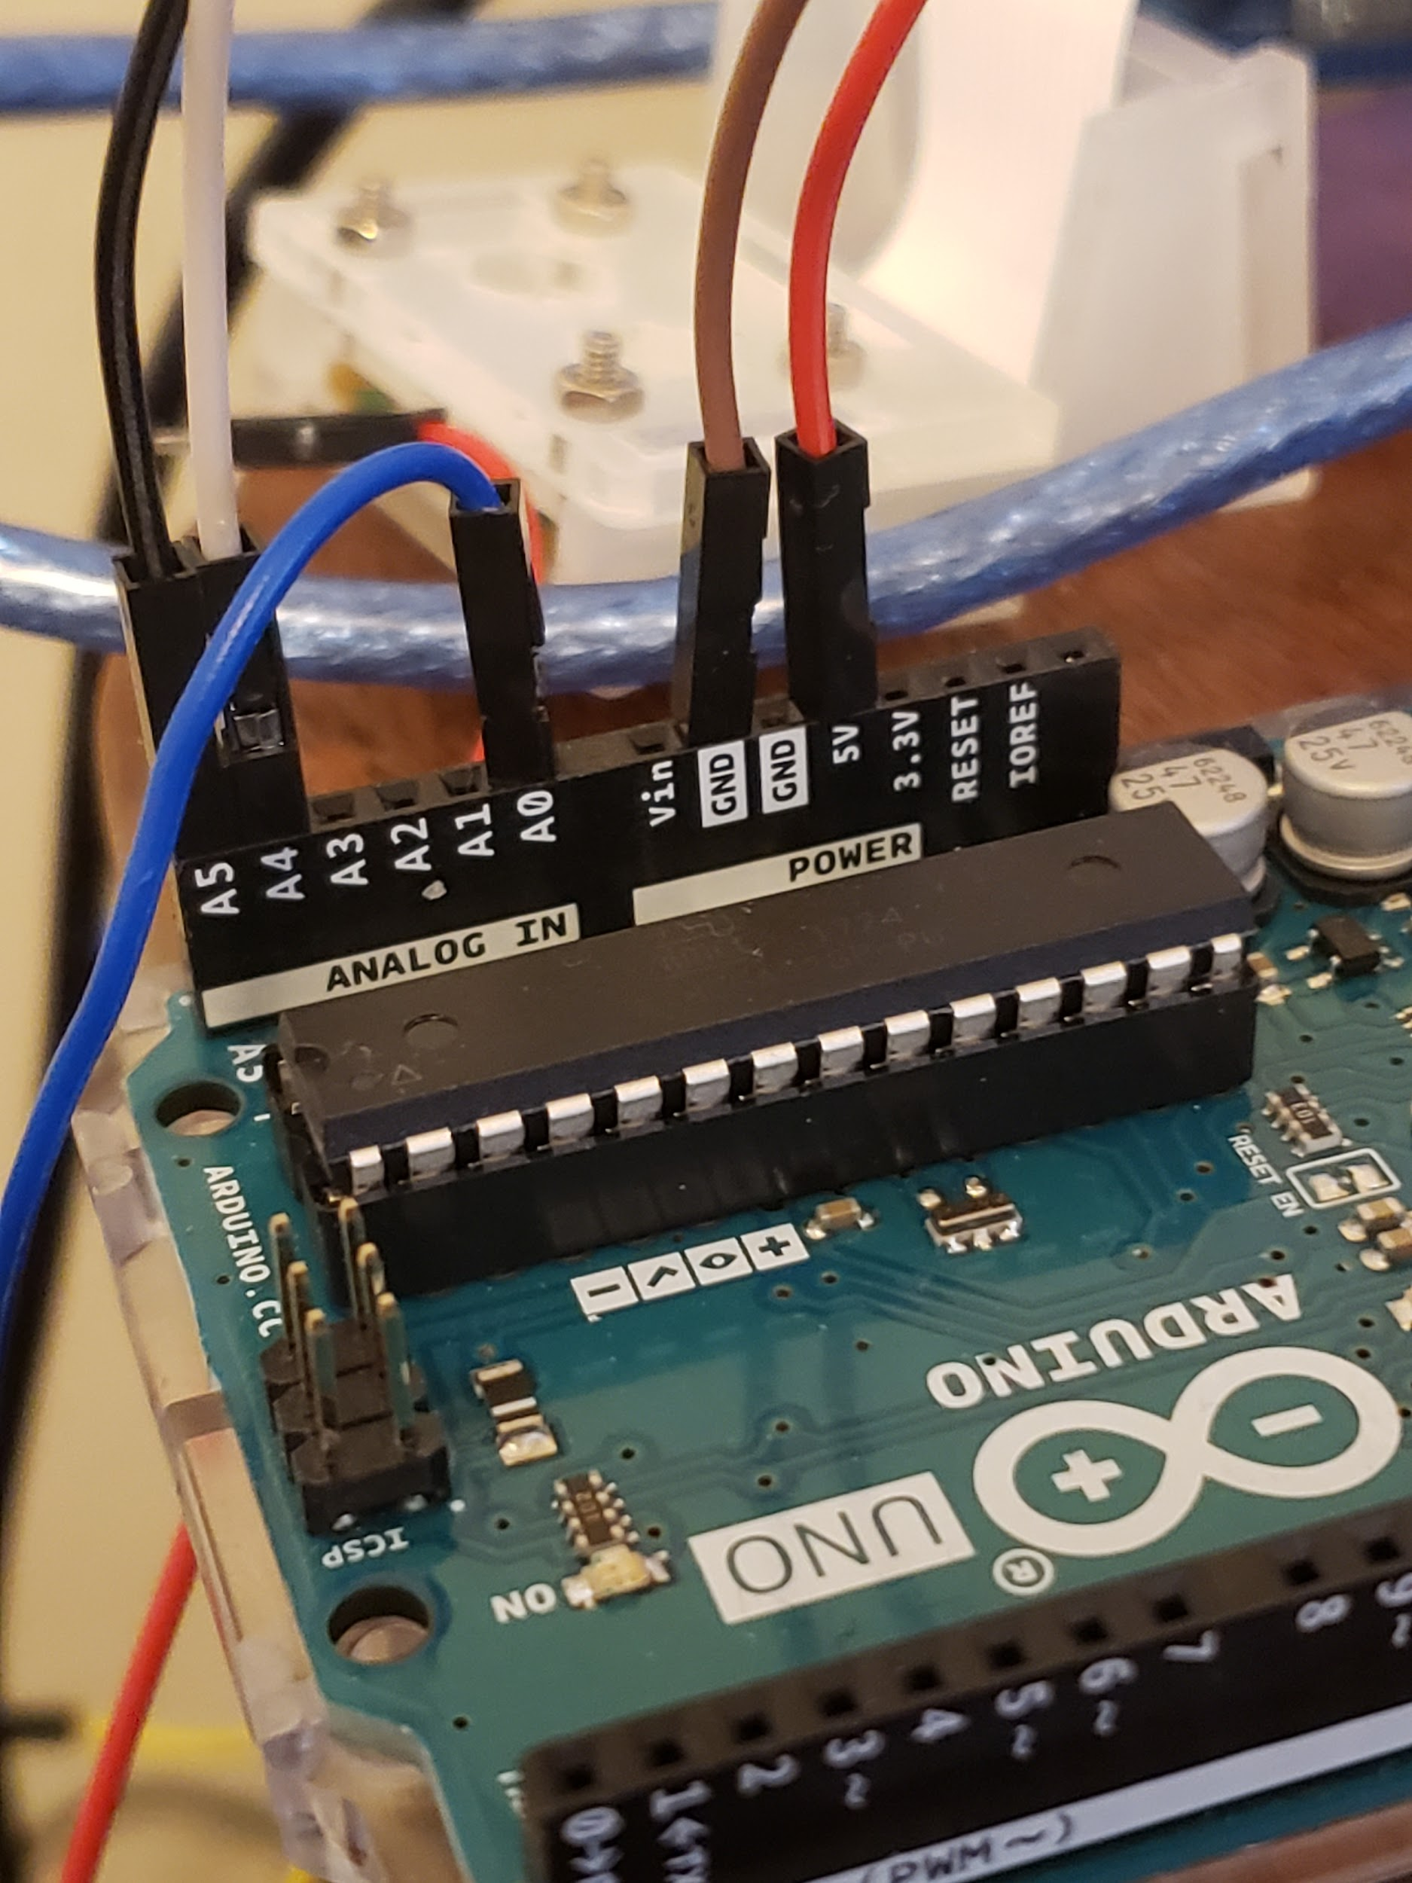

Then the power and ground cables can be plugged into the positive and negative terminals of the breadboard like so:

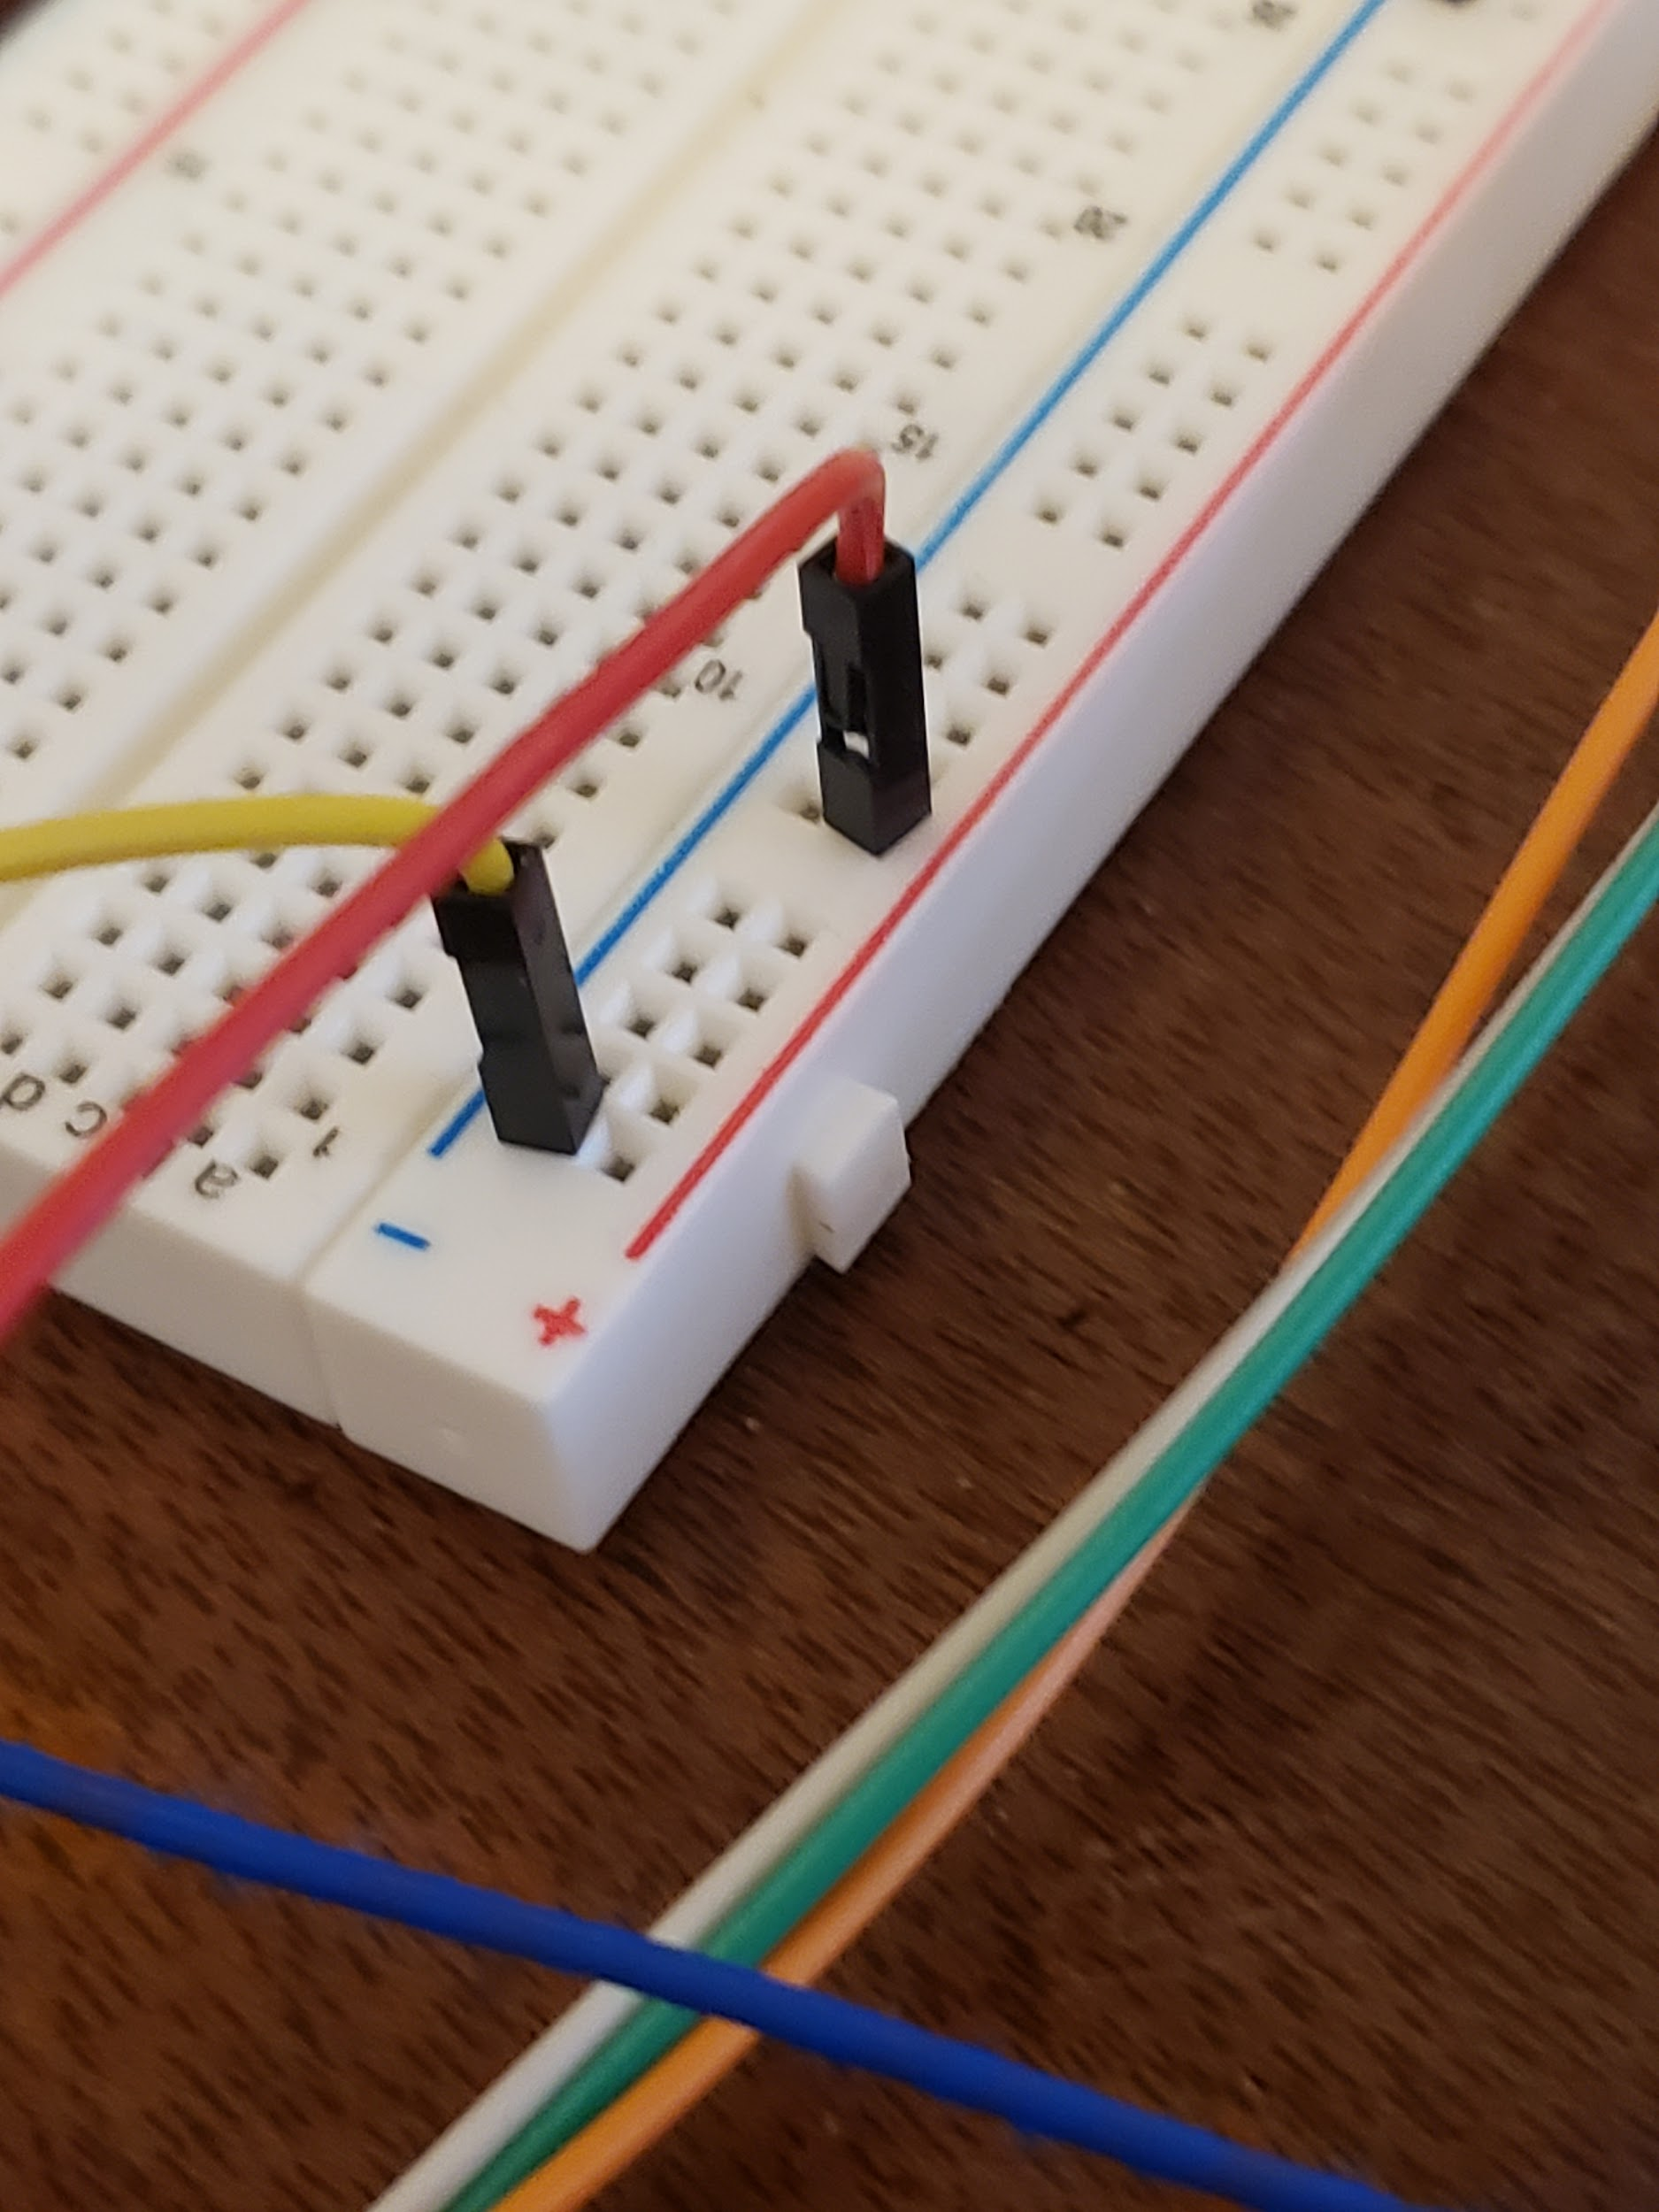

Once this is done your turbidity sensor should be fully functional. All that’s left to do is to program it.

**Programming your Arduino to Work with the Turbidity Sensor**

To program the arduino open up the Arduino IDE and put this code in:

*void setup() {*

*Serial.begin(9600);*

*}*

*void loop() {*

*int sensorValue = analogRead(A0);*

*float voltage = sensorValue * (5.0 / 1024.0);*

*float turbid = -1120.4*square(voltage) + 5742.3*voltage-4353.8;*

*if (voltage > 4.2) {*

*Serial.println(50);*

*}*

*else if (voltage < 2.5) {*

*Serial.println(3000);*

*}*

*else {*

*Serial.println(turbid);*

*delay(500);*

*}*

*}*

The formula for turbid may need to be adjusted, all you really need to know is that water should spit a value of 50 out and that as you get darker and darker liquid the value will increase. So start with the formula given, and adjust as necessary.

To see the values first save the file and then upload it. Once this is done, click the icon in the top right corner of the IDE to look at the outputs. It should look something like this:

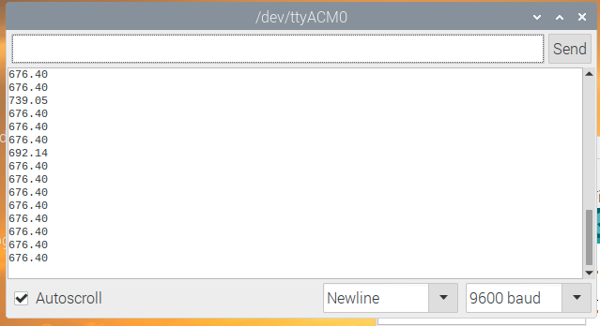

This is the sensor’s reading when not in any liquid.